E - LEARNING



*Team Members: Akanksha Kumari*

Introduction

The process of learning which is supported by the use of ICT (e.g. the Internet, network, standalone computer, interactive whiteboard or portable device).

Term covering a wide set of applications and processes, such as Web-based learning, computer based learning, virtual classrooms, and digital collaboration. It includes the delivery of content via Internet, intranet/extranet (LAN/WAN), audio- and videotape, satellite broadcast, interactive TV, CD-ROM, and more

Practical definition for the term e-learning platform:

Comprehensive software package that supports some or all aspects of course preparation, delivery and interaction, and allows these aspects to be accessible via a network.

Features:

Five common features of “e-learning systems”:

Computer-mediated communication to allow students and instructors to communicate with each other. Examples are discussion forums, messaging systems and chats.

Navigational tools organizing a site into units such as modules and lessons and granting access to the various features of the system.

Course management for keeping track of students and their records and for managing security and access rights for various user groups.

Assessment is usually provided in the form of online quizzes with immediate feedback, including a score and comments.

Authoring tools: Most course-support systems do not offer full authoring environments, but allow instructors to upload and organize material, to create discussions and quizzes, and to generally control the features offered by the system.

TABLE 1 below gives a description of the modules proposed for the E-Learning system.

TABLE 1

|  |  |  |
| --- | --- | --- |
| MODULE | OBJECTIVE | FEATURES |
| ACTIVITY LOGS | Manage activity logs | * Admin can manage the activity logs * Admin can edit/delete the activity logs * Admin can see the list of all activity logs * Teacher can see his activity logs |
| CLASS | Tracks all the information and details of classes. | * Admin can add new classes * Admin can see the list of classes details * Only admin can edit and update the record of the classes * Admin will be able to delete the records of the classes * All classes forms are validated on client side using JavaScript |
| TEACHER | Tracks all the information of the teacher. Create, Read, Update and Delete (CRUD) operations will be developed for teachers. This is a role based module where admin can perform each and every operation on data but the teacher will be able to view only his/her data. Access level restrictions will be implemented for students. | * Admin can add new teacher records * Admin can see the list of teacher details * Only admin can edit and update the record of the teacher * Admin will be able to delete the records of the teacher * All teacher forms are validated on client side using JavaScript |
| ASSIGNMENTS | Administrator to manage Assignments | * Admin can manage the assignment * Admin can edit/delete the assignment * Admin can see the list of all assignments * Teacher can see his assignment |
| DEPARTMENTS | Administrator to manage departments | * Admin can manage the departments * Admin can edit/delete the departments * Admin can see the list of all departments * Teacher can see his departments |
| EVENTS | Provides all the functionality related to events and tracks all the information and  details of events | * Admin can add new events * Admin can see the list of events details * Only admin can edit and update the record of the events * Admin will be able to delete the records of the events * All events forms are validated on client side using JavaScript |
| SUBJECTS | Administrator can add subjects and a teacher can see subjects | * Admin can manage the subjects * Admin can edit/delete the subjects * Admin can see the list of all subjects |
| STUDENTS | Tracks all the information and details of the students. Create, Read, Update and Delete (CRUD) will be developed for operations of the students. | * Admin can add new students * Admin can see the list of students details * Only admin can edit and update the records of the students * Admin will be able to delete the records of the students * All Students publication forms will be validated on the client side using JavaScript. |

Based on the modules to be created, TABLE 2 below gives a description of the functional requirements for each user.

TABLE 2

|  |  |
| --- | --- |
| USER | FUNCTIONAL REQUIREMENTS |
| ADMIN | * Login for Admin * Forgot password for Admin * Edit Profile for Admin * Change password for Admin * Logout functionality * Dashboard for Admin User * MANAGE ACTIVITY LOG: Add New Activity log, edit the existing activity log, view details of the activity log and see a listing of all activity logs * MANAGE TEACHER: Add new teacher, edit existing teacher, view details of teacher and see a listing of all teachers * MANAGE CLASS: Add new class, edit existing class, view details of a class and see a listing of all classes * MANAGE ASSIGNMENTS: Add new assignment, edit the existing assignment, view details of the assignments and see a listing of all assignments * MANAGE DEPARTMENTS: Add a new department, edit the existing department, view details of the department and see a listing of all departments * MANAGE EVENT: Add a new event, edit the existing event, view details of events and see a listing of all events * MANAGE FILES: Add new files, edit existing files, view details and a listing of all files * MANAGE STUDENT: Add new student, edit the existing student, view details of the student and see a listing of all students * MANAGE SUBJECT: Add a new subject, edit the existing subject, view details of a subject and see a listing of all subjects. * REPORTS OF THE E-LEARNING MAMAGEMENT SYSTEM: Reports of Activity logs, Teachers, Classes, Assignments, Departments, Events, Files, Students and Subjects. |
| TEACHER | * TEACHER REGISTRATION: Any Teacher can register on the website using the registration module * TEACHER LOGIN: This is the login form from where the Teacher can login into the system * TEACHER ADDS CLASS: This is the Teacher Add Class form * TEACHER ASSIGNMENTS ADD: This is the Teacher assignments add form of the project * TEACHER CLASS: This is the Teacher class in this project * TEACHER EVENT: This is the Teacher Event where a teacher will be able to add an event and see an event report * TEACHER SEND MESSAGE: This is the teacher Send Message form where the teacher will be able to send a message * TEACHER QUIZ SCREEN: This is the teacher quiz screen form where a teacher can add a quiz and see a quiz report * CHANGE PASSWORD: This is the change password module from where a teacher can change his account password. * VIDEO UPLOADING for teachers: Teachers can also upload videos to aid in teaching. |
| STUDENT | * STUDENT REGISTRATION: Any Students can register on the website using the registration module * STUDENT LOGIN: This is the login form from where students can login to the system * STUDENT VIEW ANNOUNCMENT SCREEN: Students can view announcements * STUDENT ASSIGNMENTS REPORT: This is the Student assignments report of the project * STUDENT COMPOSE MESSAGE SCREEN: Student compose message screen * STUDENT EVENT SCREEN: A student will be able to see an event report * STUDENT INBOX SCREEN: A student will be able to see a message * STUDENT QUIZ SCREEN: Student can see the quiz report * CHANGE PASSWORD: A student can change his account password from this module. |

TABLE 3 below gives a description of non-functional requirements proposed for the e learning management system.

TABLE 3

|  |  |
| --- | --- |
| NON-FUNCTIONAL REQUIREMENT | OBJECTIVE |
| Application Security | The system should be protected in such a manner that one registered user should not be able to access another registered user’s information ensuring privacy of information. |
| Database Security | Users of the system should not have direct access to the database to query it nor view data in it. The only access to the database should be via the application interface. |
| Browser Compatibility | The application should be accessible on Google Chrome, Mozilla Firefox and Internet Explorer browsers on any device. |
| Maintainability | The application should be developed so that one can easily add new products and easily facilitate changes to product information. |
| Consistency | The appearance and delivery of the content should be consistent to reduce the learning curve. Layouts, buttons and the positioning of key elements should be consistent in each page. |
| Usability | How difficult it will be to learn and operate the system. |
| Scalability | Number of users supported will mainly depend on the server load, server processing capacity and its memory. It should scale maximum number of users. |
| Availability | 24 X 7 availability should be there so that student can use it at any time according to his/her convenience. |

**Design**

The first step in the design process involved identifying use case diagrams for each user.

 Image 1 below shows the Use case diagram for the Administrator.

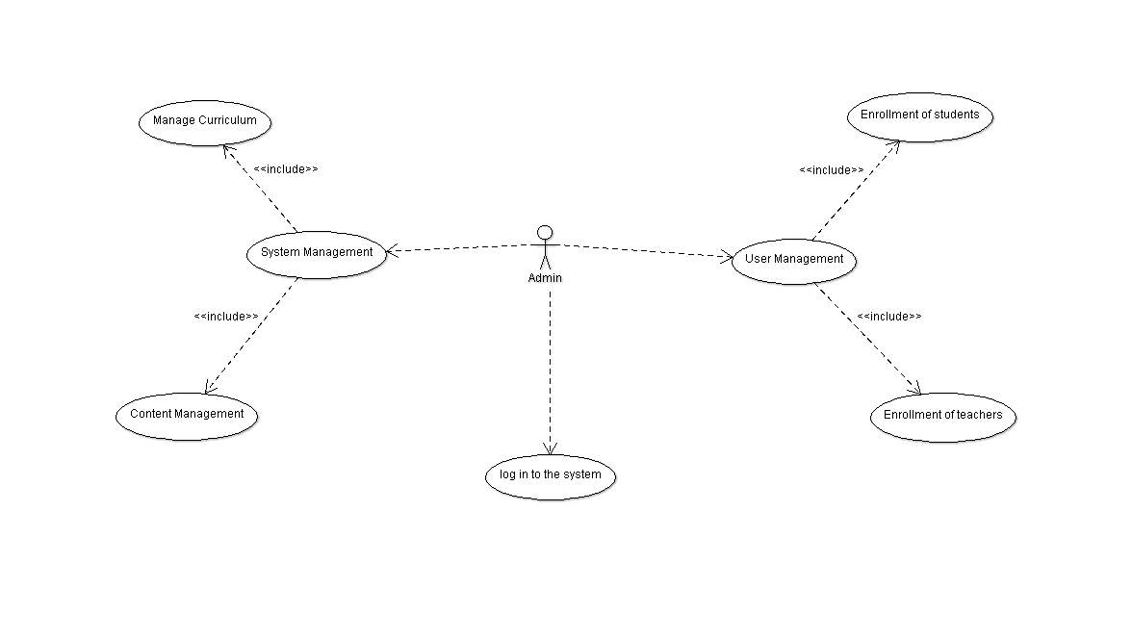

     IMAGE 1

Image 2 shows the use case diagram for Teachers

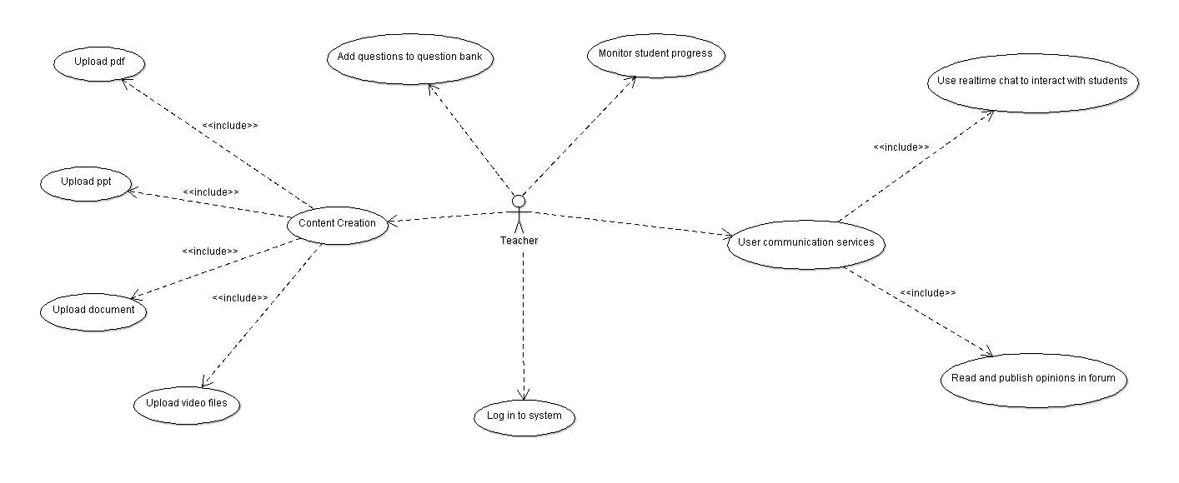

               IMAGE 2

Image 3 shows the use case diagram for Students

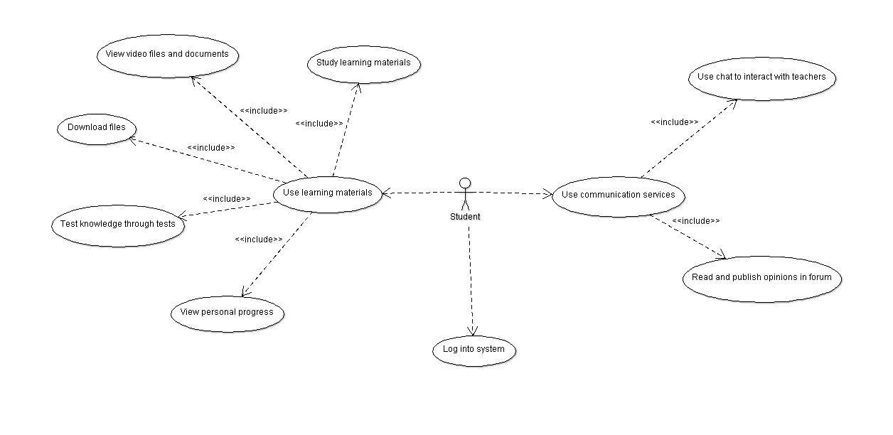

IMAGE 3

**Testing strategy**

Describe the overall approach to testing. For each major group of features or feature combinations, specify the approach which will ensure that these feature groups are adequately tested.

Specify the major activities, techniques, and tools which are used to test the designated groups of features.

The approach should be described with sufficient details to permit the identification of the major testing tasks and estimation of the time required to do each one.

**Steps**

* Test Plan
* Test Cases
* Test Incident Reports
* Test Summary Reports
* **Approvals**

**Conclusion**

This project is consisting only documentation of developing e-learning software. E-Learning now a days replacing offline system of education.